# Subsystem Services

**Student Dashboard**

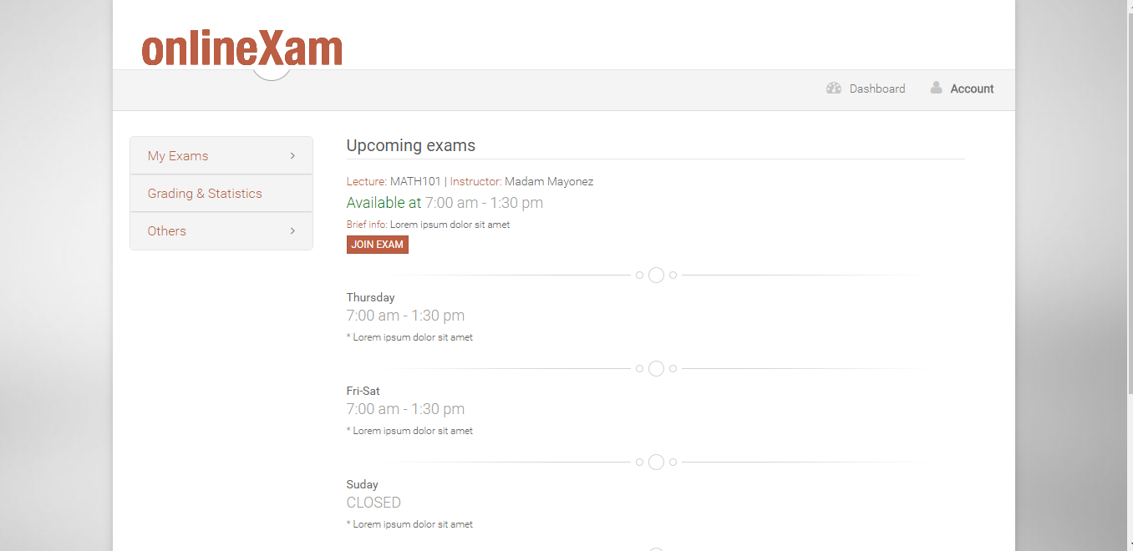

**Join Exam**

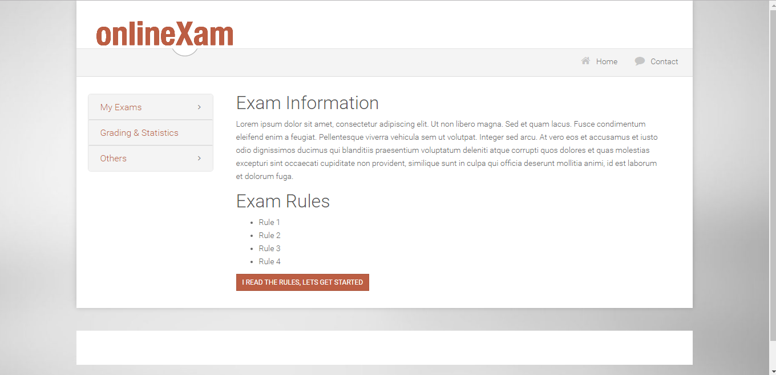

**Answer Question**

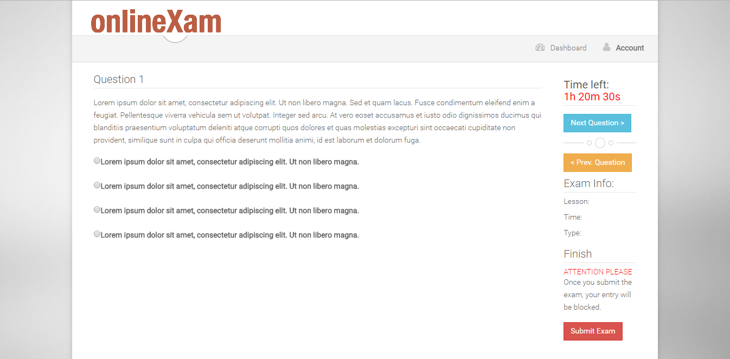

# References

1. Online homework & exam system, loncapa.isikun.edu.tr/adm/login?domain=bsu